**Project Documentation**

**Designing Visually Appealing Certificate For A Debate Competition Using Canva**

**1 Introduction**

**1.1 overview**

**sign in to your Canva account.**

**Start by searching for a certificate template. You can enter "Certificate" in the search bar, and Canva will provide a variety of options to choose from.**

**Select a layout that suits the theme of your debate competition. Canva offers a wide range of layouts to choose from.**

**Replace the default text on the template with the relevant details about the debate competition. This includes the event name, date, venue, and any additional information you want to include.**

**1.2 Purpose**

**Certificates provide participants with tangible proof of their involvement and achievements in the debate competition. This recognition is essential for their self-esteem and motivation**

**. For winners and outstanding participants, certificates can serve as awards or prizes, adding prestige to the competition and encouraging healthy competition. Certificates become memorabilia for participants to cherish and remember their participation in the debate competition.**

**2 Problem Definition & Design Thinking**

**2.1 Empathy Map**

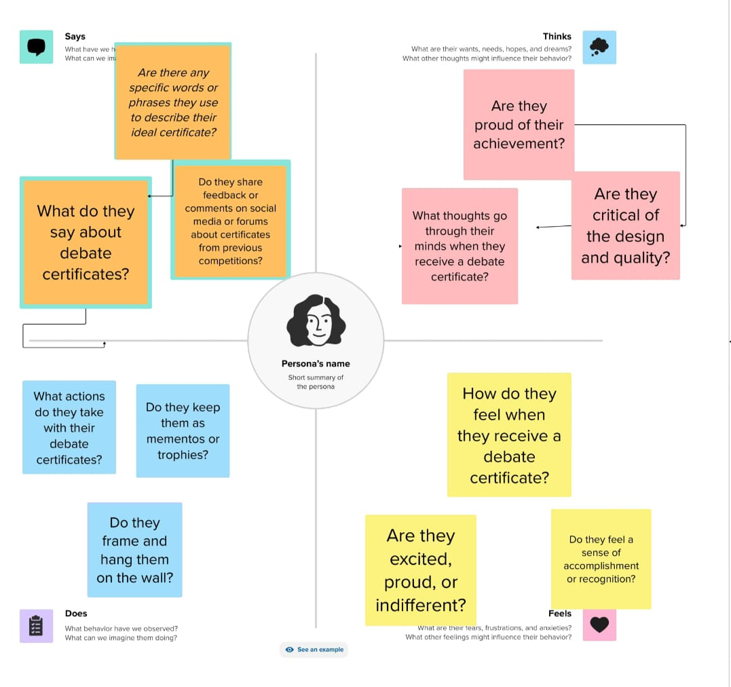

**2.2 Ideation & Brainstorming Map**

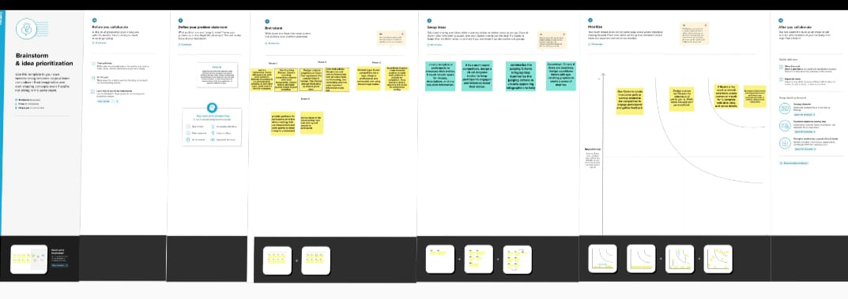

**3 Result**

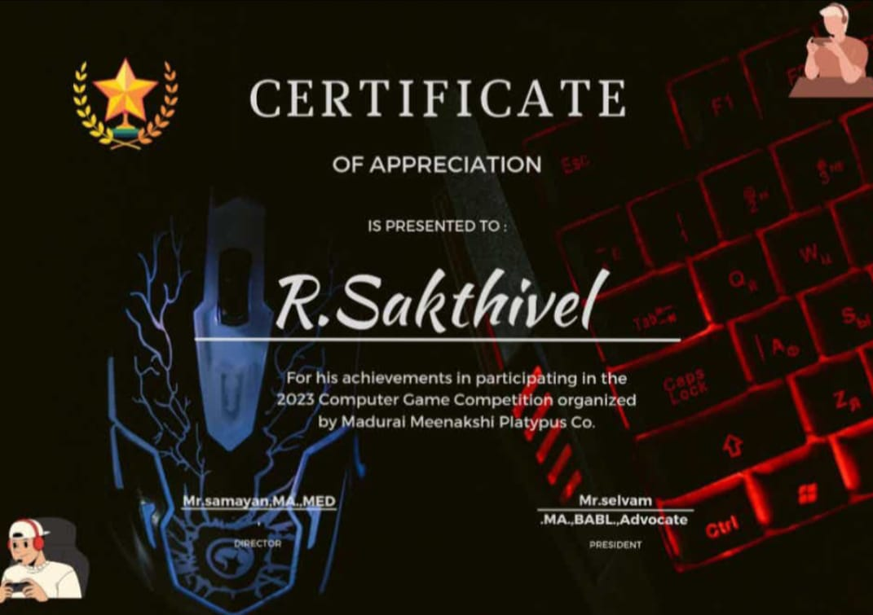

**Advantages:**

**Canva offers an easy-to-use interface with drag-and-drop functionality, making it accessible for users with various design skill levels. Canva provides a wide range of templates, fonts, colors, and images that allow you to create a certificate that aligns with the theme and branding of your debate competition. Canva offers a free version with many design elements, and the Pro version, which provides even more resources, is relatively affordable.**

**Disadvantages:**

**While Canva offers a lot of customization options, it may not be as flexible as professional design software, which can limit your design creativity. The free version of Canva includes a small watermark with their branding on your designs, which can be removed by upgrading to Canva Pro.**

**5.Application**

**Organizations that host debate tournaments or workshops can use Canva to design certificates for participants, winners, or speakers. Companies hosting debate events or team-building activities can utilize Canva for designing certificates for employees or clients. Nonprofits organizing debate-related programs or fundraisers can create certificates for volunteers, donors, or participants.**

**6.Conclusion**

**In conclusion, using Canva to design visually appealing certificates for a debate competition is a practical and accessible solution. Canva offers a user-friendly interface, a wide range of design elements, and the ability to customize certificates to match the branding and theme of your competition. The cost-efficiency of Canva, with both free and affordable Pro versions, makes it accessible to a wide range of users.**

**7.Future**

**Scope Canva may incorporate AI features that help users create more personalized and unique certificates by suggesting design elements, layouts, or color schemes based on the event's theme or the user's preferences. Canva could expand its customization options, allowing users to have even greater control over design elements, shapes, and text, making it more adaptable to unique design concepts**

**8.Appendix**

**The appendix will contain additional resources, links, or templates related to Designing visually appealing certificate for a debate competition using canva. This section will include:**

